Premier Medical Necessity (PMN) (8.5)

Please read entire document before installing

System and software prerequisites
- You must be on v8.4 of PMN before installing this release.
- Your i5/OS must be at V6R1M0 or higher for this release to function properly.

Any program found in your HS library that is also found in the release library will need to be manually updated from the release library.

Download/Upload of save file and restore library

The save file for PMN v8.5 can be downloaded PMN85 .

The zipped file downloaded from the web page will need to be unzipped and the save file uploaded to your System i5 (iSeries) after which the release library will need to be restored. There are several methods you can use to accomplish this. Below is an example of using FTP to do so.

- Extract the file pmn85 savf to a temporary directory. We’ll use c:\temp in this example.
- Create a save file on your System i5.
CRTSAVF FILE(QGPL/PMN85)
- Open a DOS window and type “cd c:\temp”

- In the same DOS window, use the 'ftp' command in Windows, to FTP 'pmn85.savf' into PMN85 in QGPL. Be sure to use the 'bin' command to change to binary mode. Here is a sample FTP session:
C:\temp>ftp nnn.nnn.nnn.nnn
Connected to nnn.nnn.nnn.nnn.
220-QTCP at (System i5 name).
220 Connection will close if idle more than 5 minutes.
User (nnn.nnn.nnn.nnn:(none)): userid
331 Enter password.
Password: XXXXX
230 USERID logged on.
ftp> bin
200 Representation type is binary IMAGE.
ftp> put pmn85.savf QGPL/PMN85
200 PORT subcommand request successful.
150 Sending file to member PMN85 in file PMN85 in library QGPL.
250 File transfer completed successfully.
8668704 bytes sent in 22.76seconds 380.19Kbytes/sec)
ftp> quit
221 QUIT subcommand received.

- From a System i5 command line, run the following command.

RSTLIB SAVLIB(PMN_V8.5) DEV(*SAVF) SAVF(QGPL/PMN85)

- On a command line, run the following command.

DLTF FILE(QGPL/PMN85)

Install Tasks

- Sign on to your System i5 with a user profile that has at least SECADM authority.
- Set your library list for the PMN environment. Should include PH/MR/EC/SC if installed.
- Add the release library to your library list (PMN_V8.5)
- On a command line type $_install and press enter. The installation notice screen displays.

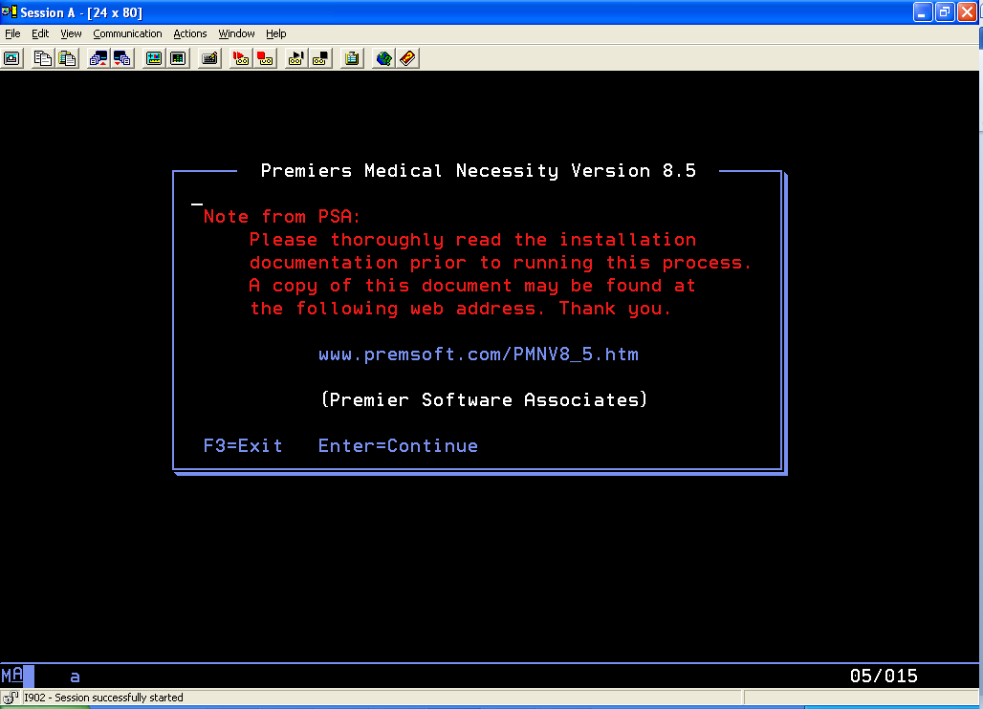

- Press Enter to continue. The environment library screen displays
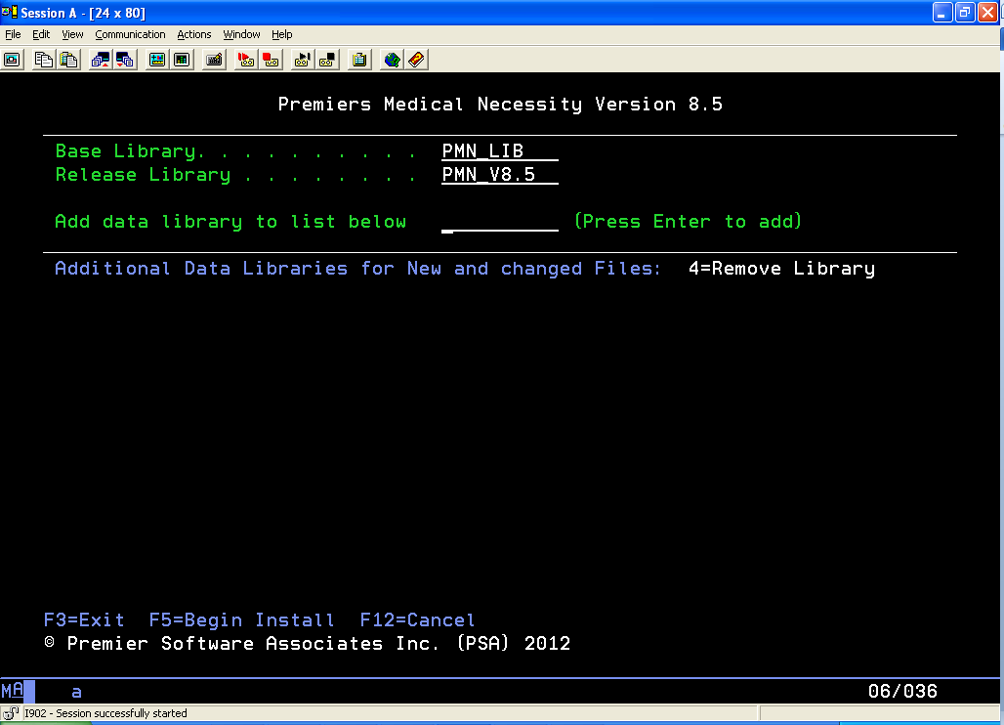

- Fill out the fields on the screen according to the following table
Field | Description
Base Library | Enter the name of the library containing the current version of PMN which is to be updated to v8.5. This library contains the PMN programs and may contain data files in a single entity environment
Release Library | Enter the name of the release library, PMN_V8.5 (or equivalent if you restored the release under a different name).
Add data library... | If your data files are kept in a library other than the base library, enter the name of the library and press enter to add the library to the list on screen. If you do not have separate data libraries, leave this field blank. If you have multiple entities which share the same base library, but have separate data libraries, you may continue to add data library names to the list by typing each library name pressing enter.  *Note – If you have multiple entities, but they do not share the base library, you must upgrade each entity separately.

- Press F5 to start the install process. The installation verification window will display.
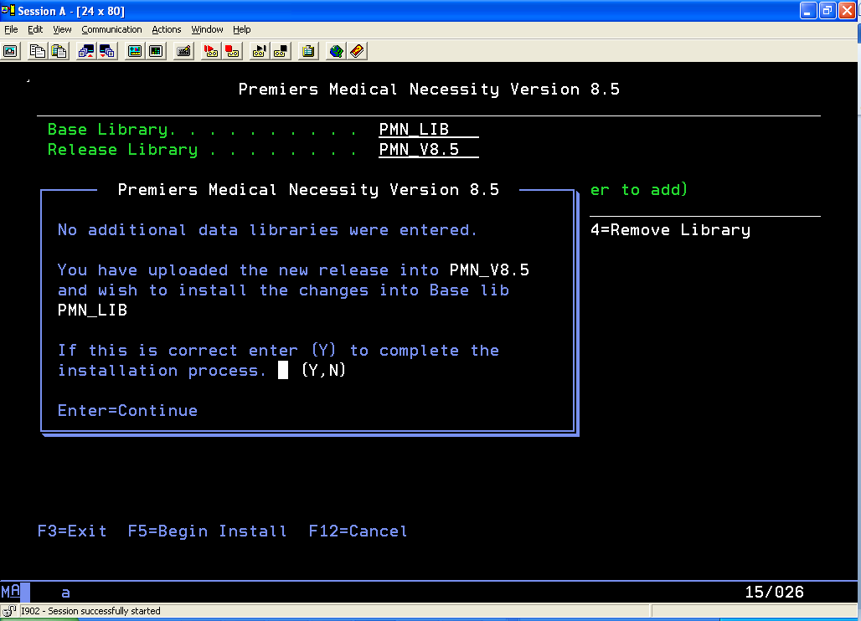

- Enter a “Y” and press enter to install the release.
- When the installation is complete the following window displays.
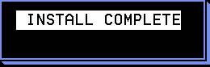

- Press enter to exit the installation program.

- Query to review the file $_INSTERP in PMN_V8.5. It will contain records of any errors which might have occurred during the install.
  - The file will list any commands that the install program ran which were not able to complete successfully.
  - Depending on your environment, you may receive the following errors on the listing. These are normal and do not require any remediation.
ERRSTR
DLTF FILE(PMN_LIB/MNABRV0P1)
DLTF FILE(PMN_LIB/MNABRV0P2)
DLTF FILE(PMN_LIB/MNICDRGP1)
DLTF FILE(PMN_LIB/MNICD10P1)
DLTF FILE(PMN_LIB/MNLOGAP6)
DLTF FILE(PMN_LIB/MNTPC4P7)
DLTF FILE(PMN_LIB/MNTPC4P8)

  - Any other commands listed in this file may require remediation. Anaylyze your environment to determine the reason for the failing command.

- Repeat steps 1-11 for any additional PMN environments which do not share the base library just upgraded.
- Additional Notes.

Additional Notes

The following programs will not compile if the current system does not have the MS4 scheduling software installed.
  - IN0205R
  - IN0003R

Any V8.5 programs existing in HS libraries will need to be recompiled.

