Premier Medical Necessity

Version 8.5

Release Notes

PREMIER SOFTWARE ASSOCIATES
997 West 950 North Suite 200
Centerville, Utah 84014
(801) 299-8772

INTRODUCTION:

Premier Software Associates is pleased to announce the release of version 8.5 of Medical Necessity. This release includes updates, software modifications and fixes to the Medical Necessity software V8.4.

The remainder of this document will outline the updates made to the product for this release.

PREREQUISITES:

You must be on Medical Necessity version 8.4 to install this release.

OVERVIEW:

Among other enhancements and fixes, this release prepares the Medical Necessity software for the use of ICD10 codes in building policies and checking accounts for Medical Necessity as per CMS guidelines. This release has been prepared under the assumption that ICD10 policies will function similarly to ICD9 policies. Future releases may be required when the final ICD10 policy formats are made available. Significant changes have also been made to accommodate future changes to use 3 character patient types.

Functional Enhancements:
Function or Screen | Description | Comments
ICD10 Maintenance | Added new file maintenance option for ICD10 codes | Found on File Maintenance Menu 2
Rebuild ICD10 Search Index | Added new function | Found on File Maintenance Menu 2
Syncronize ICD10 Files | Added new function | Found on File Maintenance Menu 2
File Maintenance Menu | Removed the password requirement window | Access to File Maintenance will still need to be granted in the Access Maintenance function.
Medical Necessity Checker | Adjusted screen to indicate ICD9 vs. ICD10 usage. | A comparison is made between the date of service and the effective date for ICD10.

Post Install Tasks:

- ICD10 Live Date
- Set the effective date for switching to using ICD10 codes for Medical Necessity checks. This step does not need to be followed immediately, but must be completed before the actual effective date for ICD10.
- From the Medical Necessity Maintenance Menu, select option 1, Carrier Type Maintenance. The Carrier Type Maintenance search and select screen displays.
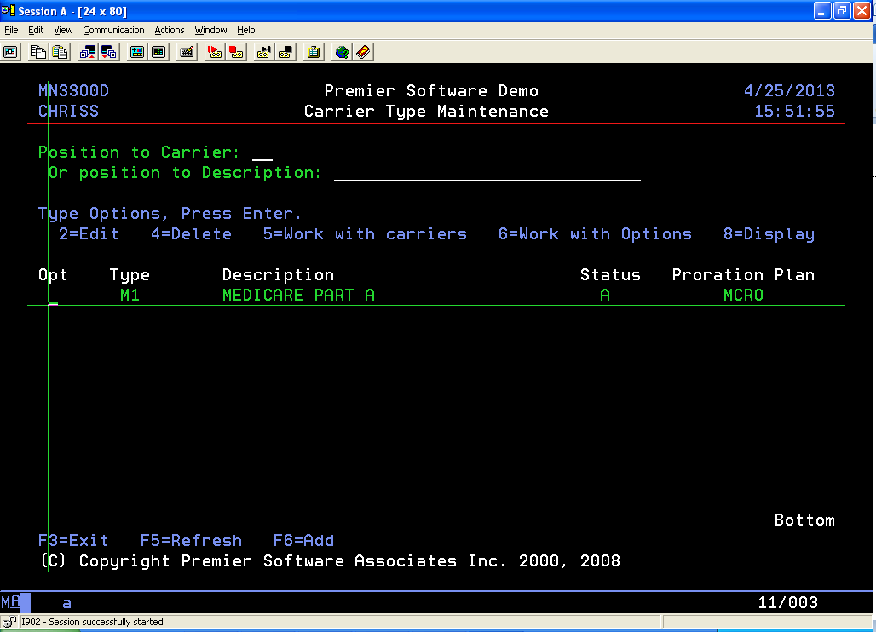
- Select the Carrier Type you wish to “Work with Options” by typing a ‘6’ in the Opt field and pressing <enter>. The Carrier Option – Page 1 screen displays. Press <Pg Dwn> to see more options.
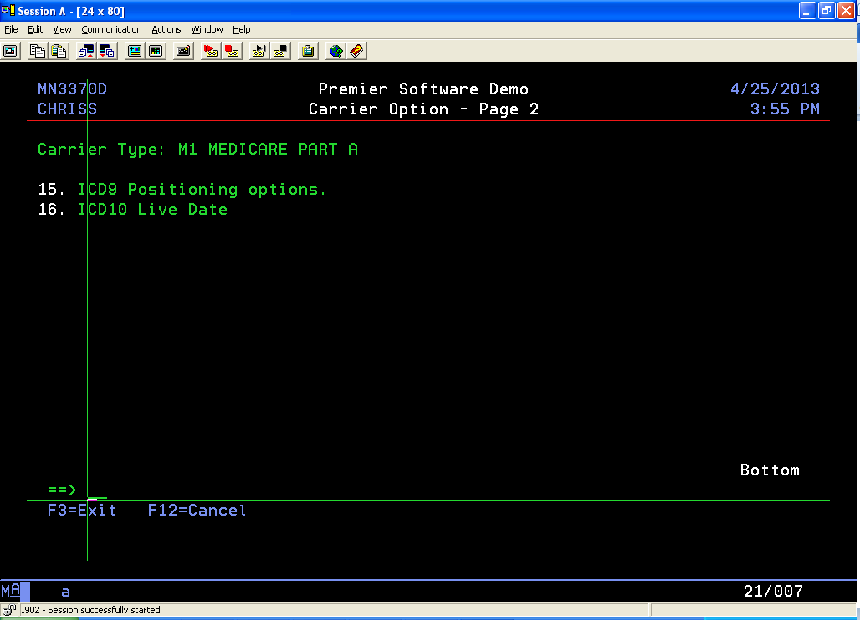
- Select “ICD10 Live Date” by typing ‘16’ and pressing <Enter>. The option record displays.
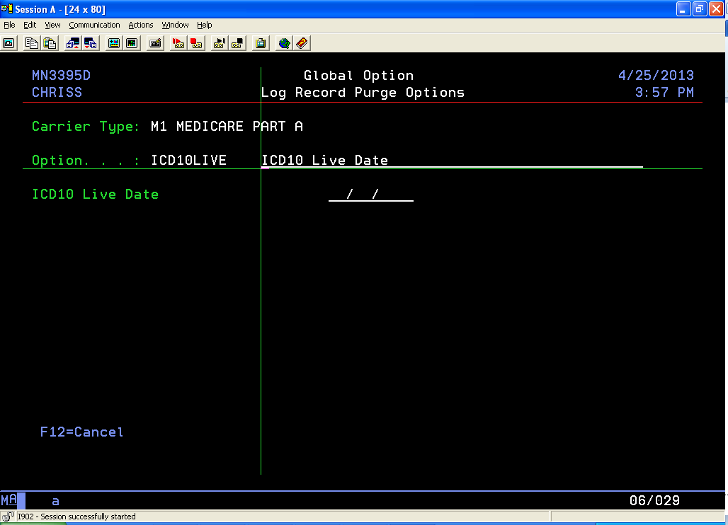
- In the “ICD10 Live Date” field, enter the effective date for ICD10 usage as determined by regulations and press <enter>.
- The Carrier Option – Page 1 screen will redisplay. Press <F3> to return to the menu.
- Synchronize ICD10 Files
- Once the MS4 ICD10 file has been populated and before the ICD10 effective date, run the “Synchronize ICD10 Files” option.
- From the Medical Necessity Maintenance Menu, select option 22, File Maintenance Menu #2. From this menu, select option 6, Synchronize ICD10 File.
- The program runs and synchronizes the files.

Objects included in this release
- The following table shows the objects included in this release and the reason for their inclusion.

Fix/Enhance | Object | Comments
Enhancement | @EXCEPT | Changed to accommodate 3 character patient type
Enhancement | @RTVCHKCAR | Changed to accommodate 3 character patient type
Enhancement | @VICD10 | New for ICD10 codes
Enhancement | FPROGRAM | Changed to accommodate 3 character patient type
Enhancement | INABNMODR | Changed to accommodate 3 character patient type
Enhancement | INEDMFTPC | New program for sending to EDM
Enhancement | INEDMFTPR | New program for sending to EDM
Enhancement | INICD10CON | Changed to accommodate 3 character patient type
Enhancement | INUB04F | Changed to accommodate 3 character patient type
Enhancement |  | Added code to process ICD10 codes
Enhancement |  | Changed to get last log record instead of first
Fix |  | Fixed loading of editor log files
Enhancement | IN0001R | Changed for 3 digit patient type
Enhancement | IN0002R | Changed for 3 digit patient type
Enhancement | IN0003R | Changed for 3 digit patient type
Enhancement | IN0006R | New program for EDM transfer
Enhancement | IN0007C | Changed for 3 digit patient type
Enhancement | IN0007R | Changed for 3 digit patient type
Enhancement | IN0008R | Changed for 3 digit patient type
Enhancement | IN0009R | New program for EDM transfer
Enhancement | IN0010R | Changed for 3 digit patient type
Enhancement | IN0011R | Changed for 3 digit patient type
Enhancement | IN0020R | Changed for 3 digit patient type
Enhancement | IN0025R | Changed for 3 digit patient type
Enhancement | IN0199R | Changed for 3 digit patient type
Enhancement | IN0200C | Changed for 3 digit patient type
Enhancement | IN0200R | Changed for 3 digit patient type
Enhancement | IN0205R | Changed for 3 digit patient type
Enhancement | IN0250R | Changed for 3 digit patient type
Enhancement | IN0651R | Changed for 3 digit patient type
Enhancement | IN2000R | Changed for 3 digit patient type
Enhancement | IN3006R | Changed for 3 digit patient type
Enhancement | IN6030R | Changed for 3 digit patient type
Enhancement | MNABRV0P | New for ICD10 abbreviations
Enhancement | MNABRV0P1 | New for ICD10 abbreviations
Enhancement | MNABRV0P2 | New for ICD10 abbreviations
Enhancement | MNACTHP | Changed for 3 digit patient type
Enhancement | MNACTHP1 | Changed for 3 digit patient type
Enhancement | MNACTHP2 | Changed for 3 digit patient type
Enhancement | MNACTHP3 | Changed for 3 digit patient type
Enhancement | MNACTHP4 | Changed for 3 digit patient type
Enhancement | MNACTHP5 | Changed for 3 digit patient type
Enhancement | MNBILTP | Changed for 3 digit patient type
Enhancement | MNBILTP1 | Changed for 3 digit patient type
Enhancement | MNBILUWP | Changed for 3 digit patient type
Enhancement | MNCONTP | Changed for 3 digit patient type
Fix | MNDCWDP | Fix for Physician report
Enhancement | MNEXPORTR | Because of change to MNTPC4P
Enhancement | MNICDRGP | New file for ICD10
Enhancement | MNICDRGP1 | New file for ICD10
Enhancement | MNICD10P | New file for ICD10 codes
Enhancement | MNICD10P1 | New file for ICD10 codes
Enhancement | MNICD10SP | New file for ICD10 codes
Enhancement | MNIMPORDC | New program for ICD10
Enhancement | MNIMPORDR | New Program for ICD10
Enhancement | MNLOGAP | Changed for 3 digit patient type
Enhancement | MNLOGAP1 | Changed for 3 digit patient type
Enhancement | MNLOGAP2 | Changed for 3 digit patient type
Enhancement | MNLOGAP3 | Changed for 3 digit patient type
Enhancement | MNLOGAP4 | Changed for 3 digit patient type
Enhancement | MNLOGAP5 | Changed for 3 digit patient type
Enhancement | MNLOGAP6 | Changed for 3 digit patient type
Enhancement | MNLOGAWCNP | Changed for 3 digit patient type
Enhancement | MNLOGAWP | Changed for 3 digit patient type
Enhancement | MNMAINT | Removed password check
Enhancement | MNMAINT2 | Changed for ICD10 codes
Enhancement | MNMAINT2D | Changed for ICD10 Codes
Enhancement | MNPARM1 | Changed for 3 digit patient type
Enhancement | MNREGP | Changed for 3 digit patient type
Enhancement | MNREGP1 | Changed for 3 digit patient type
Enhancement | MNREGP2 | Changed for 3 digit patient type
Enhancement | MNREGP3 | Changed for 3 digit patient type
Enhancement | MNREGP4 | Changed for 3 digit patient type
Enhancement | MNREGP5 | Changed for 3 digit patient type
Enhancement | MNREGP6 | Changed for 3 digit patient type
Enhancement | MNREGP7 | Changed for 3 digit patient type
Enhancement | MNTPC4P | Change for ICD10
Enhancement | MNTPC4PX | Change for ICD10
Enhancement | MNTPC4P1 | Change for ICD10
Enhancement | MNTPC4P2 | Change for ICD10
Enhancement | MNTPC4P3 | Change for ICD10
Enhancement | MNTPC4P4 | Change for ICD10
Enhancement | MNTPC4P5 | Change for ICD10
Enhancement | MNTPC4P6 | Change for ICD10
Enhancement | MNTPC4P7 | Change for ICD10
Enhancement | MNTPC4P8 | Change for ICD10
Enhancement | MNXPLCYP | Changed for 3 digit patient type
Enhancement | MN0001R | Changed for 3 digit patient type
Enhancement | MN00037 | Added option to check if passing code is  past position 10 Need new message MN00037
Enhancement | MN0002D | Change for ICD10
Enhancement | MN0002R | Changed for 3 digit patient type
Enhancement |  | Changed the way the program writes notes
Enhancement |  | Removed Check for MS4 CBO release
Enhancement | MN0003R | Changed for 3 digit patient type
Enhancement | MN0004R | New checker for ICD10
Enhancement | MN0005R | Changed for 3 digit patient type
Enhancement | MN0040R | Changed for 3 digit patient type
Enhancement |  | Removed password check
Enhancement | MN0050R | Changed for 3 digit patient type
Enhancement | MN0051R | Changed for 3 digit patient type
Enhancement | MN0060R | Changed for 3 digit patient type
Enhancement | MN0197R | Changed for 3 digit patient type
Enhancement | MN0198R | Changed for 3 digit patient type
Enhancement | MN0199R | Changed for 3 digit patient type
Enhancement | MN0200R | Changed for 3 digit patient type
Enhancement | MN0201R | Changed for 3 digit patient type
Enhancement | MN0203R | Changed for 3 digit patient type
Enhancement | MN0215R | Changed for 3 digit patient type
Enhancement | MN0249R | Changed for 3 digit patient type
Fix |  | Fixed so the overlay can be left blank
Enhancement | MN0600D | Changed for 3 digit patient type
Enhancement | MN0600R | Changed for 3 digit patient type
Enhancement | MN0610D | Changed for 3 digit patient type
Enhancement | MN0610R | Changed for 3 digit patient type
Enhancement | MN0611D | Changed for 3 digit patient type
Enhancement | MN0611R | Changed for 3 digit patient type
Enhancement | MN0613D | Changed for 3 digit patient type
Enhancement | MN0613R | Changed for 3 digit patient type
Enhancement | MN0614D | Changed for 3 digit patient type
Enhancement | MN0614R | Changed for 3 digit patient type
Enhancement | MN0615D | Changed for 3 digit patient type
Enhancement | MN0615R | Changed for 3 digit patient type
Enhancement | MN0616D | Changed for 3 digit patient type
Enhancement | MN0616R | Changed for 3 digit patient type
Enhancement | MN0618D | Changed for 3 digit patient type
Enhancement | MN0618R | Changed for 3 digit patient type
Enhancement | MN0619D | Changed for 3 digit patient type
Enhancement | MN0619R | Changed for 3 digit patient type
Enhancement | MN0620D | Changed for 3 digit patient type
Enhancement | MN0620R | Changed for 3 digit patient type
Enhancement | MN0621D | Changed for 3 digit patient type
Enhancement | MN0621R | Changed for 3 digit patient type
Enhancement | MN0700D | Changed for 3 digit patient type
Enhancement | MN0700R | Changed for 3 digit patient type
Enhancement | MN0701D | Changed for 3 digit patient type
Enhancement | MN0701R | Changed for 3 digit patient type
Enhancement | MN0702D | Changed for 3 digit patient type
Enhancement | MN0702R | Changed for 3 digit patient type
Enhancement | MN2402D | New for ICD10 Abbreviations
Enhancement | MN2402R | New for ICD10 Abbreviations
Enhancement | MN2403D | New for ICD10 Abbreviations
Enhancement | MN2403R | New for ICD10 Abbreviations
Enhancement | MN2411D | New for ICD10 Abbreviations
Enhancement | MN2411R | New for ICD10 Abbreviations
Enhancement | MN2422D | New for ICD10 Abbreviations
Enhancement | MN2422R | New for ICD10 Abbreviations
Enhancement | MN2431D | New for ICD10 Abbreviations
Enhancement | MN2431R | New for ICD10 Abbreviations
Enhancement | MN2441D | New for ICD10 Abbreviations
Enhancement | MN2441R | New for ICD10 Abbreviations
Enhancement | MN3007R | Changed to show price on CPT4 screen
Enhancement | MN3007D | Changed to show price on CPT4 screen
Enhancement | MN3011R | Re-compile due to change of MNTPC4P
Enhancement | MN3086D | Re-compile due to change of MNTPC4P
Enhancement | MN3086R | Re-compile due to change of MNTPC4P
Enhancement | MN3090R | Re-compile due to change of MNTPC4P
Enhancement | MN3201D | New for ICD10 selection
Enhancement | MN3201R | New for ICD10 selection
Enhancement | MN3208D | New for ICD10 selection
Enhancement | MN3208R | New for ICD10 selection
Enhancement | MN3213D | New for ICD10 selection
Enhancement | MN3213R | New for ICD10 selection
Enhancement | MN3214D | New for ICD10 selection
Enhancement | MN3214R | New for ICD10 selection
Enhancement | MN3221D | New for ICD10 selection
Enhancement | MN3221R | New for ICD10 selection
Enhancement | MN3241D | New for ICD10 selection
Enhancement | MN3241R | New for ICD10 selection
Enhancement | MN3250C | New for ICD10 Abbreviations
Enhancement | MN3250D | New for ICD10 Abbreviations
Enhancement | MN3250R | New for ICD10 Abbreviations
Enhancement | MN3251C | New for ICD10 Abbreviations
Enhancement | MN3251R | New for ICD10 Abbreviations
Enhancement | MN3311R | Re-compile due to change of MNTPC4P
Enhancement | MN3370D | Added option 16 for ICD10 Live date
Enhancement | MN3370R | Added option 16 for ICD10 Live date
Enhancement | MN3377D | Changed for 3 digit patient type
Enhancement | MN3377DD | Changed for 3 digit patient type
Enhancement | MN3377R | Changed for 3 digit patient type
Enhancement | MN3377RR | Changed for 3 digit patient type
Enhancement | MN3385D | Added option to check if passing code is  past position 10
Enhancement | MN3385R | Added option to check if passing code is  past position 10
Enhancement | MN3395D | New for ICD10 Abbreviations
Enhancement | MN3395R | New for ICD10 Abbreviations
Enhancement | MN340XD | Re-compile due to change of MNTPC4P
Enhancement | MN340XR | Re-compile due to change of MNTPC4P
Enhancement | MN3400D | Re-compile due to change of MNTPC4P
Enhancement | MN3400R | Re-compile due to change of MNTPC4P
Enhancement | MN3405R | Re-compile due to change of MNTPC4P
Enhancement | MN3410D | Re-compile due to change of MNTPC4P
Enhancement | MN3410R | Re-compile due to change of MNTPC4P
Enhancement | MN3420R | Changed for ICD10
Enhancement | MN3430R | Re-compile due to change of MNTPC4P
Enhancement | MN3440R | Re-compile due to change of MNTPC4P
Enhancement | MN3450R | Re-compile due to change of MNTPC4P
Enhancement | MN3460R | Re-compile due to change of MNTPC4P
Enhancement | MN3465R | Re-compile due to change of MNTPC4P
Enhancement | MN3510D | Re-compile due to change of MNTPC4P
Enhancement | MN3510R | Re-compile due to change of MNTPC4P
Enhancement | MN3511R | Re-compile due to change of MNTPC4P
Enhancement | MN3512RS | Re-compile due to change of MNTPC4P
Enhancement | MN3513R | New program for ICD10
Enhancement | MN3520D | Re-compile due to change of MNTPC4P
Enhancement | MN3520R | Re-compile due to change of MNTPC4P
Enhancement | MN3530R | Re-compile due to change of MNTPC4P
Enhancement | MN3531RS | Re-compile due to change of MNTPC4P
Enhancement | MN3550R | Re-compile due to change of MNTPC4P
Enhancement | MN3560R | Re-compile due to change of MNTPC4P
Enhancement | MN3565R | Re-compile due to change of MNTPC4P
Enhancement | MN3601D | New program for ICD10
Enhancement | MN3601R | New program for ICD10
Enhancement | MN3606R | Re-compile due to change of MNTPC4P
Enhancement | MN3610D0 | New for ICD10
Enhancement | MN3610R0 | New for ICD10
Enhancement | MN3620D0 | New for ICD10
Enhancement | MN3620R0 | New for ICD10
Enhancement | MN3621D0 | New for ICD10
Enhancement | MN3621R0 | New for ICD10
Enhancement | MN3630D0 | New for ICD10
Enhancement | MN3630R0 | New for ICD10
Enhancement | MN3631D0 | New for ICD10
Enhancement | MN3631R0 | New for ICD10
Enhancement | MN3640D0 | New for ICD10
Enhancement | MN3640R0 | New for ICD10
Enhancement | MN3650D0 | New for ICD10
Enhancement | MN3650R0 | New for ICD10
Enhancement | MN3660D0 | New for ICD10
Enhancement | MN3660R0 | New for ICD10
Enhancement | MN3661D0 | New for ICD10
Enhancement | MN3661R0 | New for ICD10
Enhancement | MN3662D0 | New for ICD10
Enhancement | MN3662R0 | New for ICD10
Enhancement | MN3663D0 | New for ICD10
Enhancement | MN3663R0 | New for ICD10
Enhancement | MN3665D0 | New for ICD10
Enhancement | MN3665R0 | New for ICD10
Enhancement | MN3670D0 | New for ICD10
Enhancement | MN3670R0 | New for ICD10
Enhancement | MN3671D0 | New for ICD10
Enhancement | MN3671R0 | New for ICD10
Enhancement | MN3672D0 | New for ICD10
Enhancement | MN3672R0 | New for ICD10
Enhancement | MN3673D0 | New for ICD10
Enhancement | MN3673R0 | New for ICD10
Enhancement | MN3674D0 | New for ICD10
Enhancement | MN3674R0 | New for ICD10
Enhancement | MN3675D0 | New for ICD10
Enhancement | MN3675R0 | New for ICD10
Enhancement | MN3700R | Re-compile due to change of MNTPC4P
Enhancement | MN3800R | Re-compile due to change of MNTPC4P
Enhancement | MN3900D | Changed for 3 digit patient type
Enhancement | MN3900R | Changed for 3 digit patient type
Enhancement | MN3910D | Changed for 3 digit patient type
Enhancement | MN3910R | Changed for 3 digit patient type
Enhancement | MN3920D | Changed for 3 digit patient type
Enhancement | MN3920R | Changed for 3 digit patient type
Enhancement | MN3930D | Changed for 3 digit patient type
Enhancement | MN3930R | Changed for 3 digit patient type
Enhancement | MN3960R | Changed for 3 digit patient type
Enhancement | MN4000D | Changed for 3 digit patient type
Enhancement | MN4000R | Changed for 3 digit patient type
Enhancement | MN4010D | Changed for 3 digit patient type
Enhancement | MN4010R | Changed for 3 digit patient type
Enhancement | MN4020R | Changed for 3 digit patient type
Enhancement | MN4030R | Changed for 3 digit patient type
Enhancement | MN4200D | Changed for 3 digit patient type
Enhancement | MN4200R | Changed for 3 digit patient type
Enhancement | MN4201R | Changed for 3 digit patient type
Enhancement | MN4210D | Changed for 3 digit patient type
Enhancement | MN4210R | Changed for 3 digit patient type
Enhancement | MN4220D | Changed for 3 digit patient type
Enhancement | MN4220R | Changed for 3 digit patient type
Enhancement | MN4230D | Changed for 3 digit patient type
Enhancement | MN4230R | Changed for 3 digit patient type
Enhancement | MN4249R | Changed for 3 digit patient type
Enhancement | MN4250R | Changed for 3 digit patient type
Enhancement | MN4251R | Changed for 3 digit patient type
Enhancement | MN4252R | Changed for 3 digit patient type
Enhancement | MN4301R | Changed for 3 digit patient type
Enhancement | MN4310R | Changed for 3 digit patient type
Enhancement | MN4320R | Changed for 3 digit patient type
Enhancement | MN4320RPT | Changed for 3 digit patient type
Enhancement | MN6000D | Changed for 3 digit patient type
Enhancement | MN6000R | Changed for 3 digit patient type
Enhancement | MN6010D | Changed for 3 digit patient type
Enhancement | MN6010R | Changed for 3 digit patient type
Enhancement | MN6015D | Changed for 3 digit patient type
Enhancement | MN6015R | Changed for 3 digit patient type
Enhancement | MN6020R | Changed for 3 digit patient type
Enhancement | MN8000C | Changed for 3 digit patient type
Enhancement | MN8000R | Changed for 3 digit patient type
Enhancement | MN8001R | Changed for 3 digit patient type
Enhancement | MN8001SQL | Changed for 3 digit patient type
Enhancement | MN8025D | Changed for 3 digit patient type
Enhancement | MN8025R | Changed for 3 digit patient type
Enhancement | MN8030R | Changed for 3 digit patient type
Fix | MN8030RPT | Fix to Physician report
Fix | MN8035R | Fix to Physician report
Enhancement | MN8040C | Changed for 3 digit patient type
Enhancement | MN8040R | Changed for 3 digit patient type
Enhancement | MN8051R | Changed for 3 digit patient type
Enhancement | MN8054RR | Changed for 3 digit patient type
Enhancement | MN8055C | Changed for 3 digit patient type
Enhancement | MN8055D | Changed for 3 digit patient type
Enhancement | MN8055P | Changed for 3 digit patient type
Enhancement | MN8055R | Changed for 3 digit patient type
Enhancement | MN8055RR | Changed for 3 digit patient type
Enhancement | MN8056RR | Changed for 3 digit patient type
Enhancement | MN8060R | Re-compile due to change of MNTPC4P
Enhancement | MN8061R | Re-compile due to change of MNTPC4P
Enhancement | PROTOTYPES | Changed for 3 digit patient type

